GIT Configuration

Download Git from below link

<https://git-scm.com/download/win>

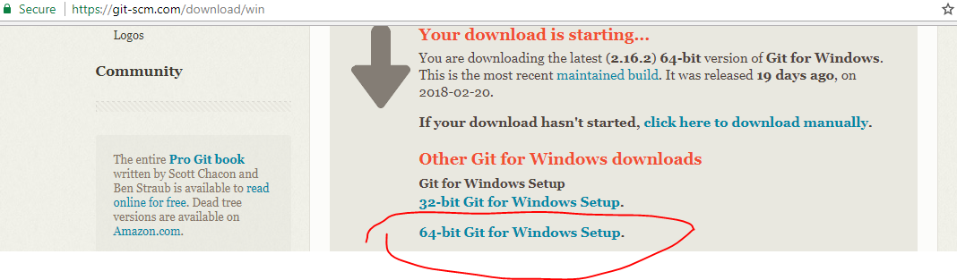

Execute it…just follow -🡪 GIT Install -🡪 Configure it—

Email name

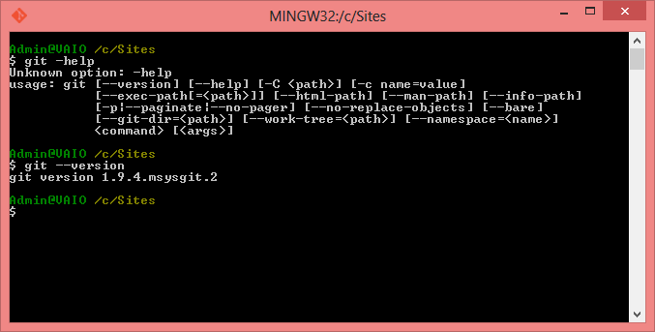

**Checking Your Settings**

If you want to check your configuration settings, you can use the git config --list command to list all the settings Git can find at that point:

$ git config --list

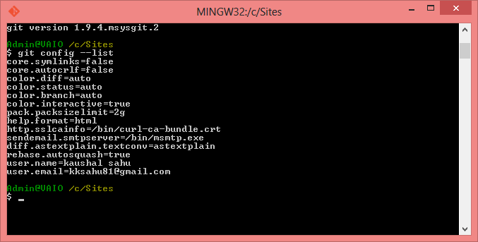

## Getting Help

If you ever need help while using Git, there are two equivalent ways to get the comprehensive manual page (manpage) help for any of the Git commands:

$ git help <verb>

git help config

$ git help config

Launching default browser to display HTML ...

Admin@VAIO /c/Sites

$

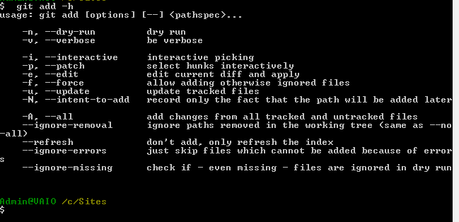

### Initializing a Repository in an Existing Directory

If you have a project directory that is currently not under version control and you want to start controlling it with Git, you first need to go to that project’s directory. If you’ve never done this, it looks a little different depending on which system you’re running:

C:\\Users\\Admin\\Desktop\\Devops\\myrepo

cd C:\\Users\\Admin\\Desktop\\Devops\\myrepo

git init

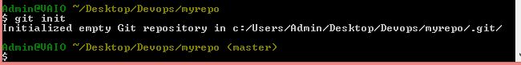

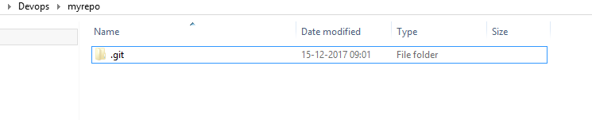

This creates a new subdirectory named .git that contains all of your necessary repository files — a Git repository skeleton. At this point, nothing in your project is tracked yet.

git add weblogic.rb

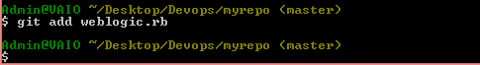

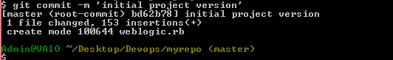

$ git status

On branch master

nothing to commit, working directory clean

Admin@VAIO ~/Desktop/Devops/myrepo (master)

$

$ git status

On branch master

Changes to be committed:

(use "git reset HEAD <file>..." to unstage)

new file: example.txt

Admin@VAIO ~/Desktop/Devops/myrepo (master)

$

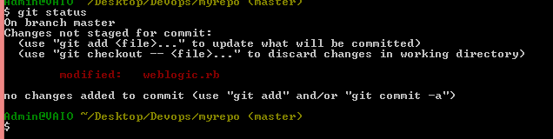

$ git log HelloWorld.java

commit 5628b01f848a121213c8158fd69ef717e700dafe

Author: kaushal sahu <kksahu81@gmail.com>

Date: Tue Feb 6 21:33:27 2018 +0530

commit

commit cd7bac060ce2bf418abc79a95414d1ef45bf80e1

Author: kaushal sahu <kksahu81@gmail.com>

Date: Mon Feb 5 00:37:52 2018 +0530

java file

Admin@VAIO MINGW64 ~/Desktop/Nandeesh-devops/first-repo (master)

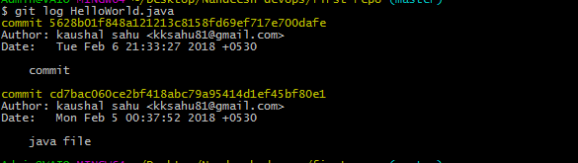

Git cherry-pick commitid ----------🡪 To merge individual commits separately.